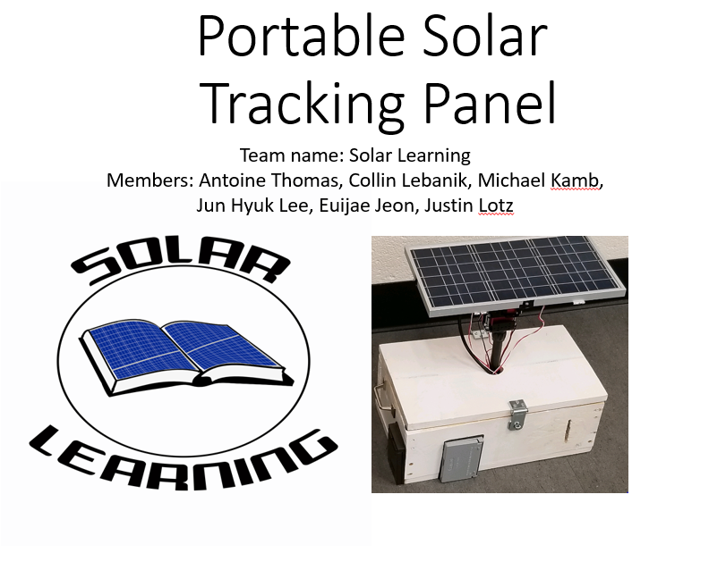

Sponsored by Dr. Hannemann

**Table of Contents**

Introduction: page 2

Part Specifications: pages 3-4

Basic Operation Instructions: pages 4-7

Part Troubleshooting: pages 7-8

Code Troubleshooting: page 8-9

Safety: page 10

1

**Introduction**

The Solar Learning portable solar panel project was created for the STEM outreach program at UK. The project is an example for k-12 students of what they could be able to create, and to get them interested in the possibility of joining the STEM field in the future.

We constructed it from several premade parts that will be discussed in more detail in the part specs section of this manual. The box was crafted by hand with parts from hardware stores and simple tools such as a drill and a dremel. The total cost of the project was $494.71 with tax included for everything. The box cost was $125 this cost could have been lowered slightly but we wanted the box to be as water resistant as possible.

The parts were tested to make sure that they all worked as expected, all of the parts passed testing and were able to be implemented together with very few problems.

2

**Part Specifications**

**Solar Panel Specifications:**

* 10 Watts rated power output
* .51 Amps rated current output
* Dimensions: 13.8 x 8.6 x 1.3 inches

**Inverter Specifications:**

* Two 110v Ac outlets
* 4 USB ports with a max output of 6.2A
* Silent cooling fan and led indicator
* Intelligent LCD Display screen
* On/Off switch for AC outlets
* Weight of 12.7 ounces
* Dimensions: 7.4 x 5.2 x 1.5 inches

**Charge Controller Specification:**

* Optimized for a 12V/24V system.
* Rated Charge current: 10A
* Self-Consumption: <10mA
* Max. PV Input Voltage: 130W / 12V; 260W / 24V
* Working Temperature: -31°F ~ 113°F
* Dimensions: 4.68 x 2.95 x 1.08 inches
* Weight: 0.27lbs
* Grounding Type: Negative
* Backlit LCD screen displays system operation, diverse load control, and error codes.
* Integrated 5V 2A USB ports to charge USB devices.
* RS232 Communication Port for BT-1 Bluetooth module and usage of Renogy DC Home App.

3

**Battery Specification:**

* Optimized for a 12V system.
* LiFePO4 type battery
* Run up to 4 in series (max 48V), no limit in parallel.
* Dimensions: 3.96 x 5.91 x 3.99 inches
* Weight: 3.5 lbs
* Capacity: 12Ah (12000mAh)
* Cell balancing and low voltage/over voltage protection, short-circuit protection.
* Built-in Bluetooth module=

**Basic Operation Instructions**

**Setup**

The diagram below is the connection diagram of the whole system:

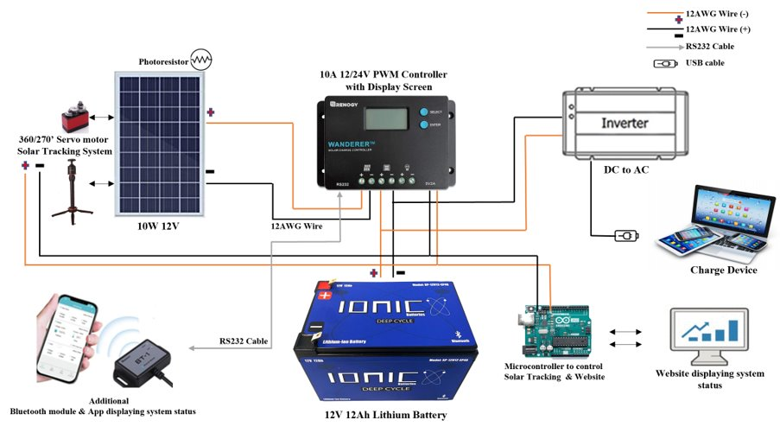

4

* The solar panel should be connected to two left terminals on the charge controller.
* The battery should be connected to two middle terminals on the charge controller. The battery also has its own application called “Ionic Blue Batteries”. You only need the Bluetooth to use this application.
* The inverter should be connected to the battery using a cigarette port adaptor.
* The Bluetooth Module should be connected to the RS323 port on the charge controller, and it allows user to use “Renogy BT” application to monitor the solar power system.
* The microcontroller for the solar tracking system and the website should be connected to the USB port on the charge controller. Make sure the Load is turned on and it can be done by pressing the Enter button on the charge controller.

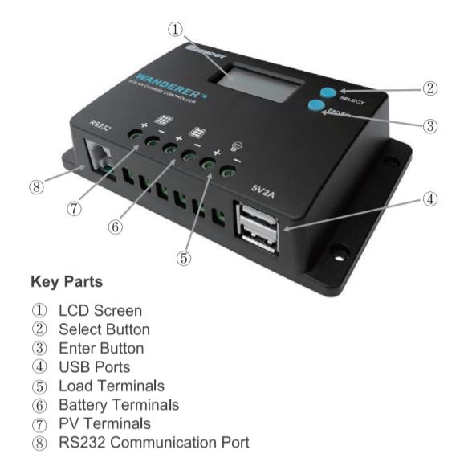

5

The charge controller has few different display options shown in images on the next page:

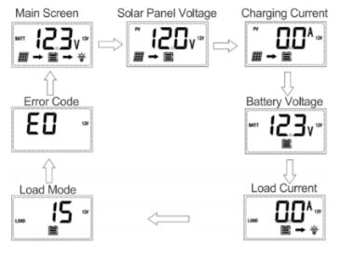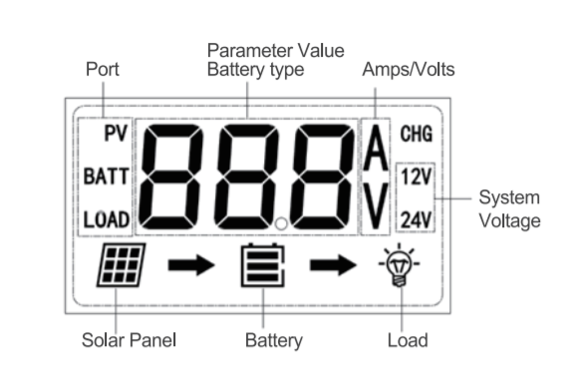

The charge controller also has different modes for the load terminal. To enter the load programming settings, hover over the Load Mode screen using the Select button. When you reach the Load Mode screen, hold the Enter button then the number will start to flash. Cycle through the Load types using the Select button and press Enter button to finalize selection.

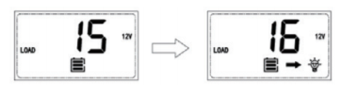

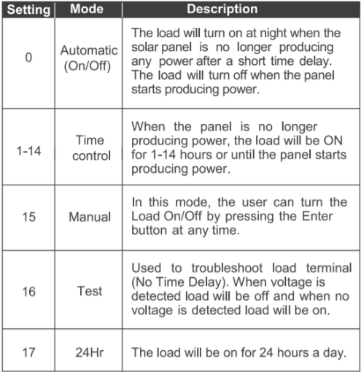

6

The system is set to 15 at the default which is the Manual Mode. So, the Load can be turned on/off using the Enter button. When the Arduino is not working, make sure the Load is turned on.

The inverter has an on/off switch that can be used to turn on/off the three prong ports. It is a nice feature to have but the need to turn off the three prong ports was never thought of as needed.

Once everything is connected, the system should operate. If the system is not operating, check and make sure all connections going into and from the controller are tight.

**Part Troubleshooting**

If the inverter is not working, there are a few things that should be checked. The first thing to check is to make sure the inverter is plugged all the way into the adaptor as if it is not all the way in then it will not function. The second thing to look at would be the fuse for the adaptor. The adaptor has a built-in fuse that will pop if the load is too much.

To check this there is a screw connection on the red wire of the adaptor. Twist the connection until it comes undone and check the fuse. If the fuse is blown the metal inside will not be connected and the glass could potentially be grey. If the metal line is still connected and the glass is still clean, then the fuse is not blown, and it could be one last problem. The last troubleshooting technique is the fuse inside the inverter itself. This one is a bit trickier to check due to the inverter having to be taken out of the box, some screws having to be taken off the inverter to get inside of it. The same general ideas apply to this fuse as the adaptor fuse. These are the recommended troubleshooting method if the inverter is not working.

7

**Warning:** Connect battery terminals to the charge controller BEFORE connecting the solar panel(s) to the charge controller. NEVER connect solar panels to charge controller until the battery in connected.

**Code Troubleshooting**

The device is not sending data to the ThingSpeak site

* This is most likely caused by the device not being able to connect to the internet. The code that is running on the Arduino, which can be found on GitHub at "link", includes a secrets.h file which contains the name and password of the network the Arduino will attempt to connect to. If the device is being brought somewhere different than its last location, you will need to change these values in the secrets.h file to match the network you want to join and then re-upload the solarLearningDevice.c file to the Arduino. The two files need to be in the same folder on your computer when you upload the solarLearningDevice.c code from the Arduino IDE (the Arduino App).

To upload the file from your computer you will need to unplug the Arduino from the USB port on the charge controller and plug it into your computer instead. The Arduino IDE should automatically detect what COM port the Arduino is on, but should you run into issues uploading the code, check your device manager to double check that the correct COM port is listed at the bottom right of the Arduino IDE. Also in the bottom right of the IDE, it should list the Arduino model as "Arduino Uno WiFi Rev2."

8

* This issue could also be caused by an interruption in the internet connection, which disconnects the Arduino. If this is the case, simply press the reset button on the Arduino located on the same end as the USB cord. This will rerun the connection code and should get the Arduino back on the WiFi network.

The device will not face the sun

* This could be caused by a number of things. Start by checking that all four photoresistors are attached to the sides of the panel securely and perpendicularly so that they are all facing the same way the solar panel is.
* If the photoresistors are not the issue, make sure the stand is still tight at the ball joint in the base and the collar beneath the servos. If either of these locations are loose, the torque from the servos may twist the stand and make it appear that the solar panel is not moving at all.
* If neither of those were the issue check that the wires for the servos and the photoresistors are not wrapped around the stand more than once or twice. If they are wrapped too tightly, you will need to manually unwrap them so that the device is free to spin again without these wires becoming tangled.
* If none of these workarounds seem to get the solar panel moving, it simply may be too much of an overcast day for the tracking system to find a better angle for the solar panel.

10

9

**Safety**

Prevention

* Do NOT touch wires while system is active to avoid electric shock.
* Only open housing unit to hook up battery leads and power inverter for use.